📘 Software Maintenance and Reuse – Notes
✅ Definition of Software Maintenance
Software Maintenance is the process of modifying software after delivery to:
- Fix bugs
- Improve performance
- Adapt to new environments
- Add new features

🛠️ Need for Software Maintenance
Maintenance is required to:
- Correct faults (bugs)
- Improve software design
- Add new features (enhancements)
- Make it work with new hardware/software
- Upgrade legacy software
- Retire outdated software

🤔 Why is Modification Needed?
- Market Conditions: Policy changes (e.g. taxes, business rules)
- Client Requirements: Customers want new features
- Host Modifications: Hardware/OS/platform changes
- Organization Changes: Business restructuring or expansion

🔄 Types of Software Maintenance
- Corrective Maintenance
Fixing bugs or performance issues
- Adaptive Maintenance
Updating software to run on new platforms or OS
- Perfective Maintenance
Adding new features or improving functionality
- Preventive Maintenance
Making changes to avoid future issues

💸 Cost of Maintenance
- Maintenance costs are more than 50% of total SDLC costs.
- Factors increasing cost:
  - Aging software is harder to maintain
  - Trial & error by inexperienced engineers
  - Poor documentation of changes
  - 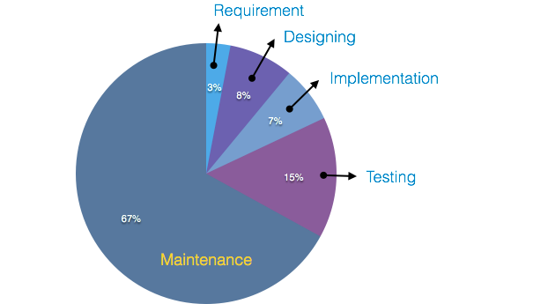

🧩 Factors Affecting Maintenance Cost
🔹 Real-World Factors
- Technology changes
- Aging hardware
- Lack of documentation
- Inexperienced staff
🔹 Software-End Factors
- Software structure
- Programming language used
- External dependencies
- Staff availability

⚙️ Maintenance Activities
- Identification & Tracing
Detect issues or user requests
- Analysis
Check how changes affect the system
- Design
Design changes based on requirements
- Implementation
Code the new or updated modules
- System Testing
Integration testing with new and old modules
- Acceptance Testing
User testing to verify correctness
- Delivery
Deploy changes and provide training if needed
- Maintenance Management
Use version control tools for managing updates
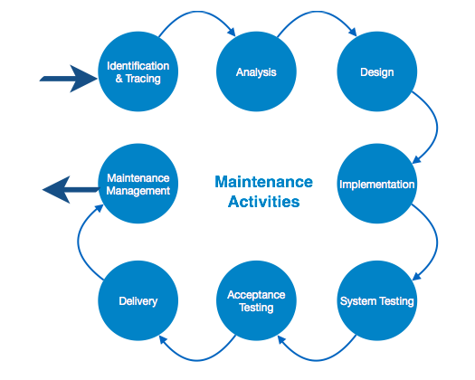

🧪 Software Maintenance Models
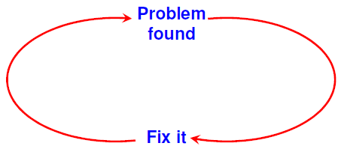
1. Quick-Fix Model
- Immediate, temporary fixes to problems
- No structured process
- High risk of damaging original software structure
2. Iterative Enhancement Model
- Treats changes as a cycle of small updates
- Steps:
  - Analyze requirements
  - Classify changes
  - Implement & document updates
3. Reuse-Oriented Model
- Based on software reengineering
- Reuse old components by:
  - Reverse engineering (extracting design & requirements)
  - Forward engineering (applying new changes)
  - 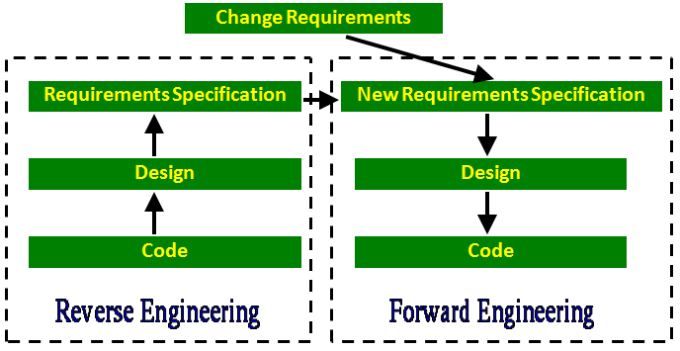

………………………………………………………

🔁 Software Reuse
🧠 Definition
Software Reuse means using existing software components (code, designs, test cases, etc.) to build new software.
It reduces:
- Development time
- Cost
- Errors
Items that can be reused:
- Requirements specification
- Design documents
- Source code
- Test cases
- Technical knowledge

⚙️ Basic Issues in a Reuse Program
- Component Creation
Identify and create reusable components that can work in other systems.
- Component Indexing & Storing
Store and classify components in databases (e.g. RDBMS or ODBMS) for easy retrieval.
- Component Searching
Provide efficient search tools so developers can find components that meet their needs.
- Component Understanding
Ensure components are:
  - Well-documented
  - Easy to understand
  - Simple to use
- Component Adaptation
Sometimes, reusable components need to be modified to fit new requirements.
But modifying too much may cause errors – careful adaptation is key.
- Repository Maintenance
Maintain the component database by:
  - Adding new components
  - Fixing bugs in old ones
  - Removing obsolete parts
- Domain Analysis
Analyze problem domains to identify reusable pieces for future use.

✅ Advantages of Software Reuse
- Reduces development cost
- Saves time
- Improves software quality
- Minimizes effort for testing and debugging
- Enables use of tried and tested components

🛠️ The Reuse Approach
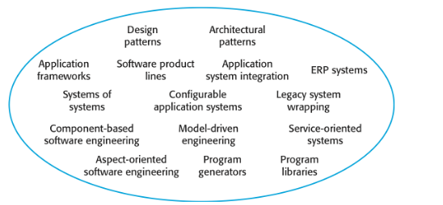
Software reuse can occur at many levels:
- Small functions or modules
- Full software libraries
- Even entire application systems
This broad scope is known as the reuse landscape.

📋 Key Factors for Reuse Planning
Before starting reuse, consider:
- Project timeline and deadlines
- How long the software will be used
- Team's experience and skill level
- Importance and safety of the software
- Type of software and its use-case
- The platform it will run on (e.g. Windows, Linux, Mobile)

